Bilingual and Arabic Design Significance in Dubai
Focus Keyword: Bilingual and Arabic Design
Meta Title: Bilingual and Arabic Design Significance in Dubai Explained
Meta Description: Learn why bilingual and Arabic design is essential in Dubai. Discover how English and Arabic visuals improve branding, reach wider audiences, and boost trust.
Feature Image:
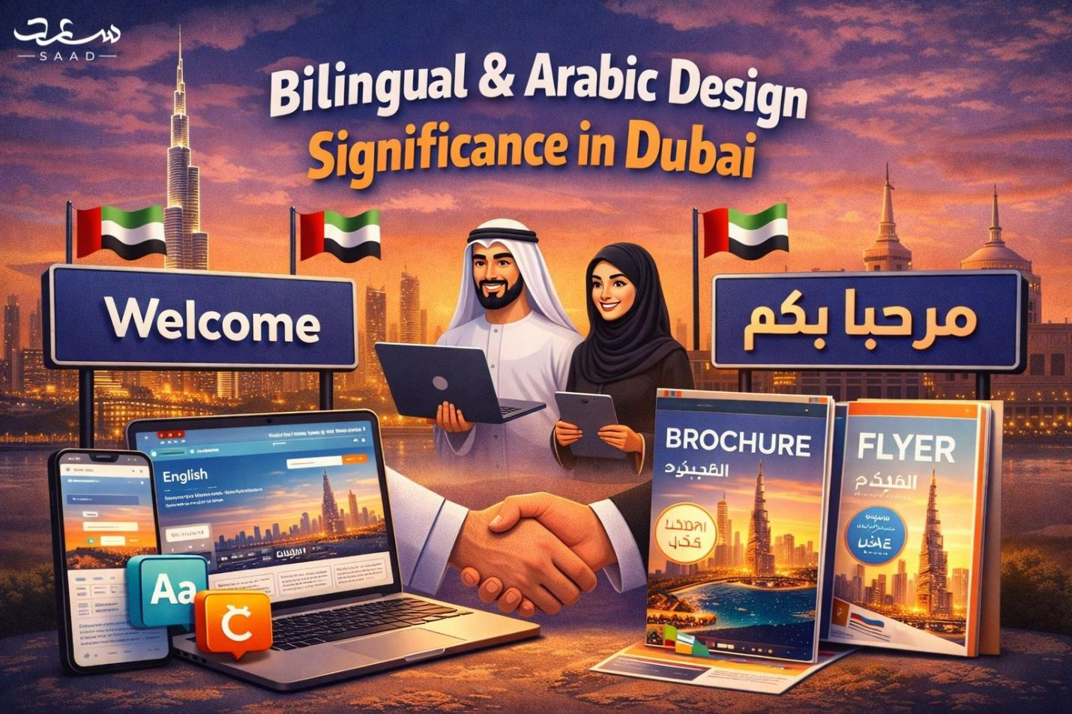

Dubai unites cultures of the world by conducting business and innovation. The brands have to address the various audiences on a daily basis. Easy communication gains credibility and trust. The power of visual identity in this process is strong. Firms require designs that are multi-faceted. The official language in the UAE is Arabic. English encourages international trade and tourism development. Both languages should be respected by the businesses. Good branding is one that relates with customers on an emotional and cultural level. Intelligent choices in design enhance brand identity in a short period. Adaptive companies are more readily accepted in the market. This article justifies the importance of bilingual design in Dubai. It also demonstrates the strategic benefits that business can have.

Why Dubai Needs Designing Culture Sensitively.
Dubai is a home to a variety of nationalities. Every single culture is concerned with identity and language. These cultural expectations should be observed by the brands. Regional traditions should be considered in visual elements. Colors, typography, and layout influence perception of the audience. The Arabic language has got the cultural and religious implications. The designers should not use insensitive symbols or words. An organization with a culturally sensitive brand creates a long-term loyalty. Companies which do not respect culture stand to lose their credibility. The culture awareness enhances the clarity of communication. Firms need to make visuals both audience-friendly. This is a method that raises brand relevance in competitive markets.

Language and Business Communication
Customers perceive brands in terms of language. Effective marketing is enhanced immediately with clear messaging. Arabic conveys power and local identification. English links up with foreign inhabitants and investors. A combination of the two is guaranteed to reach more and to know more. The branding of English Arabic builds even communication strategies. Companies communicate to various audiences without fear. Dual language messaging eliminates confusion to a great extent. It also makes cross platform engagement a notch higher. Tone and brand voice are preserved in proper translation. Literary translation mistakes should be avoided in companies. The professional design incorporates language in layouts. Understandable language presentation prompts enhanced customer relations.

Bilingual Visual Identity.
Good bilingual identity facilitates business growth. Dubai is a city that is appealing to investors around the globe. Brands have to communicate with locals and expatriates. bilingual design Dubai enhances the cross-cultural appeal. This is a way of enhancing visibility in competitive industries. When brands speak their language, customers feel appreciated. Languages that go well together make it professional. Bilingual content enhances marketing. It also enhances brand recall among the audiences. Coherent design brings about coherent messaging throughout. Companies that embrace the use of bilingual images increase at a faster rate. They gain better market positions at the local market.

The effects of Arabic Typography on Brand Perception.
Typography is very much touching on emotions. The Arabic writing is graceful and historic. The designers need to select fonts conscientiously and in a respectful manner. The Arabic graphic design Dubai needs cultural knowledge. When fonts are paired, it is important to ensure there is visual harmony. The spacing and alignment of Arabic letters should be balanced. Mistyped text may be detrimental to brand loyalty. Arabic typography is well drawn and is authentic. It also promotes luxury perception of the premium brands. Clearly written scripts enhance readability in printed and electronic copies. The practice of professional performance is respectful to tradition. Considerate typography gives strength to general brand identity.

Building Trust with Local and Expat Audiences
Trust drives long term business success. Local audiences prefer brands that respect Arabic language. Expats feel comfortable with clear English communication. Balanced design builds equal respect for both groups. UAE bilingual branding creates inclusive brand experiences. Customers feel understood and appreciated. Trust increases when messaging feels culturally aware. Businesses gain credibility through consistent presentation. Clear bilingual visuals reduce confusion in marketing. Strong trust leads to customer loyalty and referrals. Inclusive branding supports sustainable business growth.

Legal and Cultural Considerations in UAE Branding
The UAE maintains clear advertising guidelines. Brands must follow language compliance rules strictly. Arabic often appears first in official communication. Designers must respect this legal requirement. Cultural symbols require careful usage. Religious references demand sensitivity and respect. Misuse can damage brand reputation instantly. Professional designers understand these local standards. They ensure compliance across campaigns and platforms. Legal awareness protects businesses from penalties. Respectful branding strengthens public image significantly.

Digital Presence and Multilingual Website Strategy
Most customers search online before purchasing. Websites must support dual language navigation clearly. multilingual design UAE improves digital accessibility. Users can switch languages easily. Clear menus enhance browsing experience greatly. Search engines rank bilingual websites better locally. Optimized content increases organic traffic significantly. Mobile responsiveness remains equally important. Digital clarity reduces bounce rates quickly. Businesses that invest in bilingual websites grow faster. Strong digital presence strengthens competitive positioning.

Packaging and Print Design for Diverse Consumers
Packaging influences purchase decisions instantly. Clear bilingual labels improve product understanding. Customers prefer transparent information presentation. Arabic logo design enhances authenticity in local markets. Print materials must balance both languages properly. Visual alignment ensures readability and appeal. Dual language brochures expand marketing reach. Proper spacing prevents design clutter. Professional packaging builds premium perception. Effective print design supports brand recognition everywhere. Smart packaging increases shelf visibility and trust.

Competitive Advantage Through Strategic Branding
Strong bilingual branding creates clear differentiation. Businesses gain advantage over single language competitors. Clear messaging increases customer engagement rates. Dual language visuals show cultural intelligence. This approach attracts investors and partners. It enhances brand value in regional markets. Professional execution reflects market awareness. Brands that adapt remain future ready. Strategic branding supports long term profitability. Bilingual design drives measurable business success.

Choosing the Right Design Partner in Dubai
Selecting the right designer ensures success. Experience matters in bilingual communication projects. A skilled freelancer understands local expectations clearly. Saaddesign delivers culturally aligned branding solutions. The freelancer combines creativity with strategy. Clients receive tailored design support. Professional collaboration ensures smooth project execution. Quality design strengthens brand credibility quickly. Businesses should choose experts carefully. The right partner transforms vision into impact.

Conclusion
Arabic and bilingual design shapes brand success in Dubai. Businesses must communicate clearly with diverse audiences. Cultural respect builds strong emotional connections. Strategic design improves trust and engagement levels. Brands that adopt bilingual identity grow confidently. Digital and print platforms require balanced presentation. Compliance and professionalism protect brand reputation. Choosing experienced designers ensures effective execution. Strong bilingual design reflects respect and intelligence. Partnering with experts like saaddesign builds credibility and trust. Invest in bilingual branding today for long term success.

FAQs
1. Why is bilingual branding important in Dubai?
It connects local and international audiences effectively.
2. Should Arabic appear first in branding?
Yes, UAE guidelines often require Arabic prominence.
3. Does bilingual design improve SEO?
Yes, it increases regional search visibility.
4. Can poor translation harm a brand?
Yes, it damages credibility and trust.
5. Is bilingual packaging necessary in UAE?
Yes, it ensures clarity and compliance.
